Sprint - 1

|  |  |
| --- | --- |
| Date | 17 November 2022 |
| Team ID | PNT2022TMID11603 |
| Project Name | Smart Fashion Recommender Application |

Creating Register/login page Register Page:-

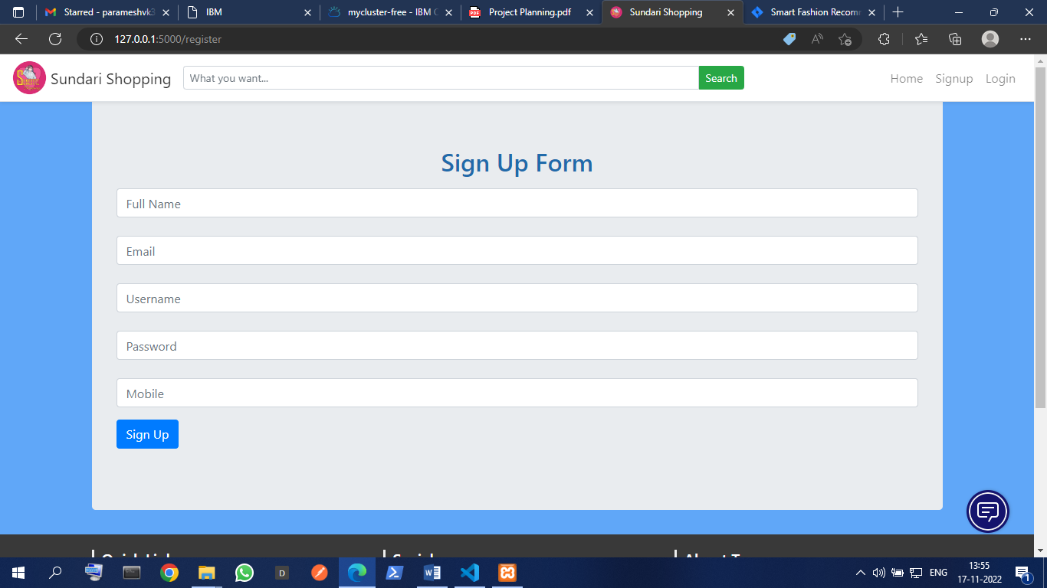

Login Page:-

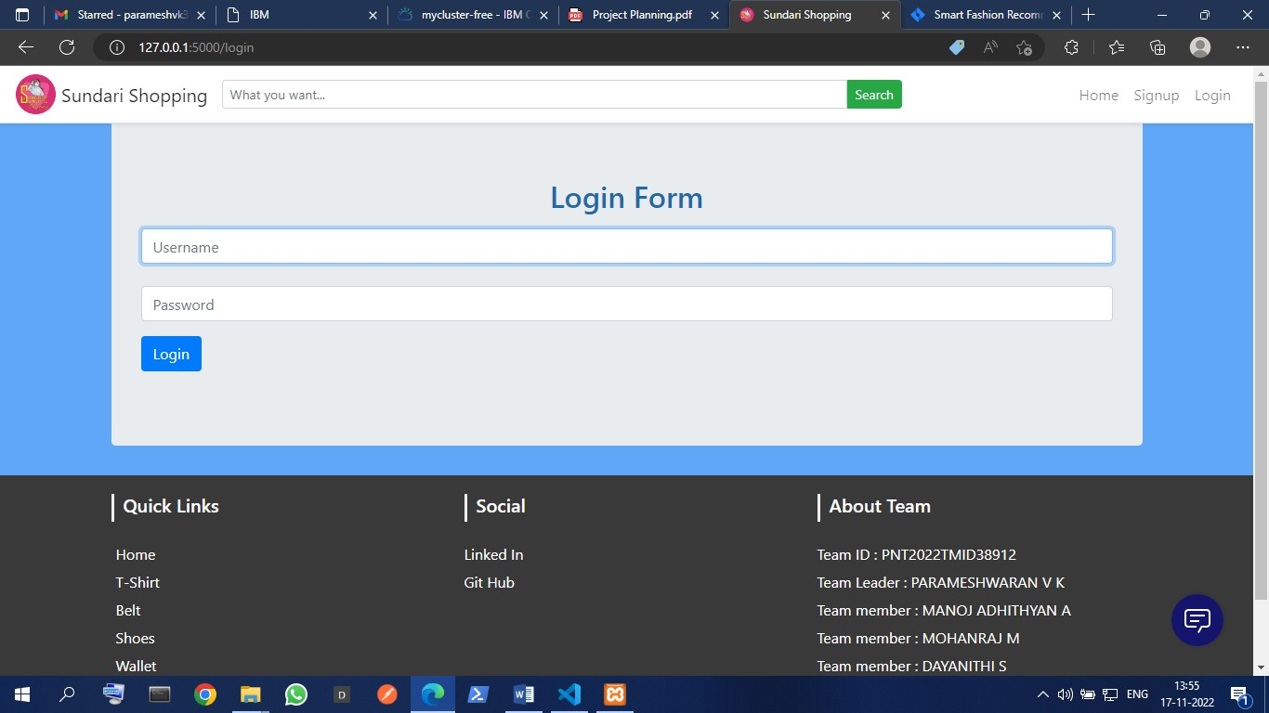

home page of e-commerce website:-

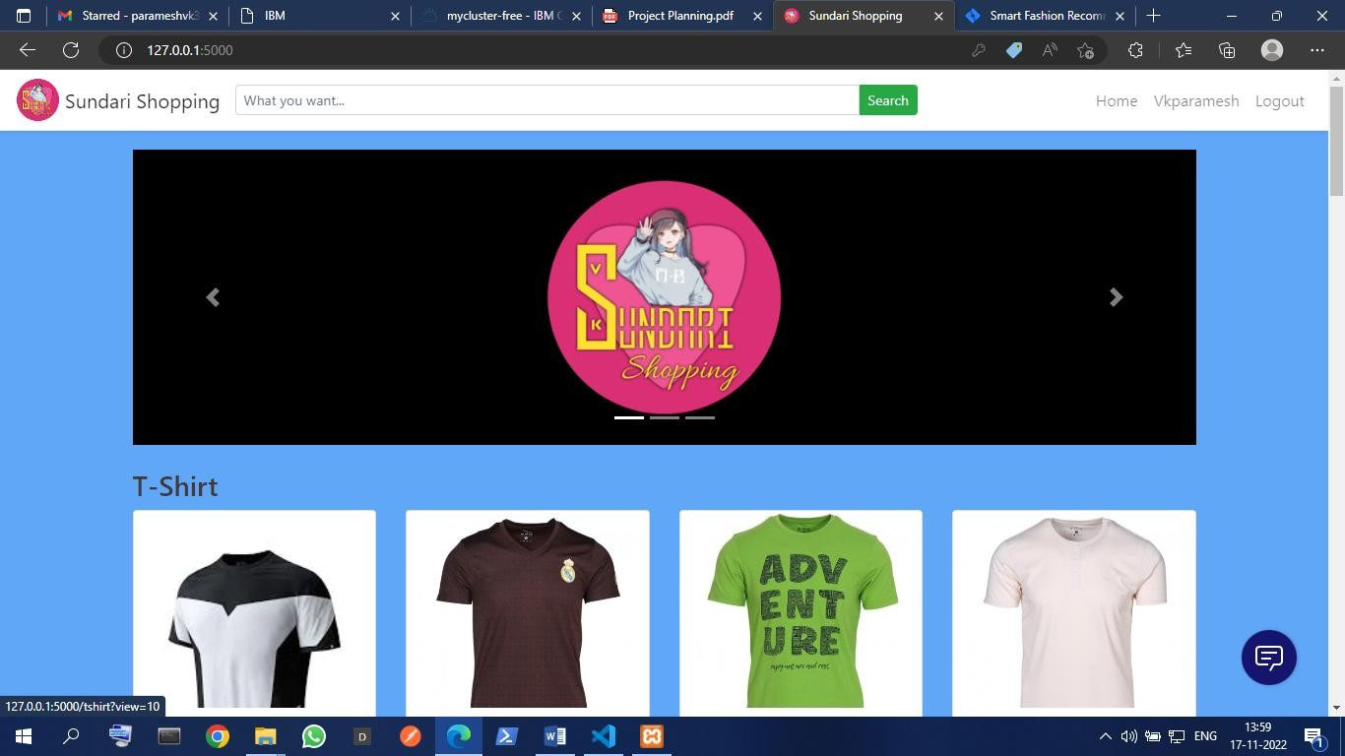

Creating buying products page

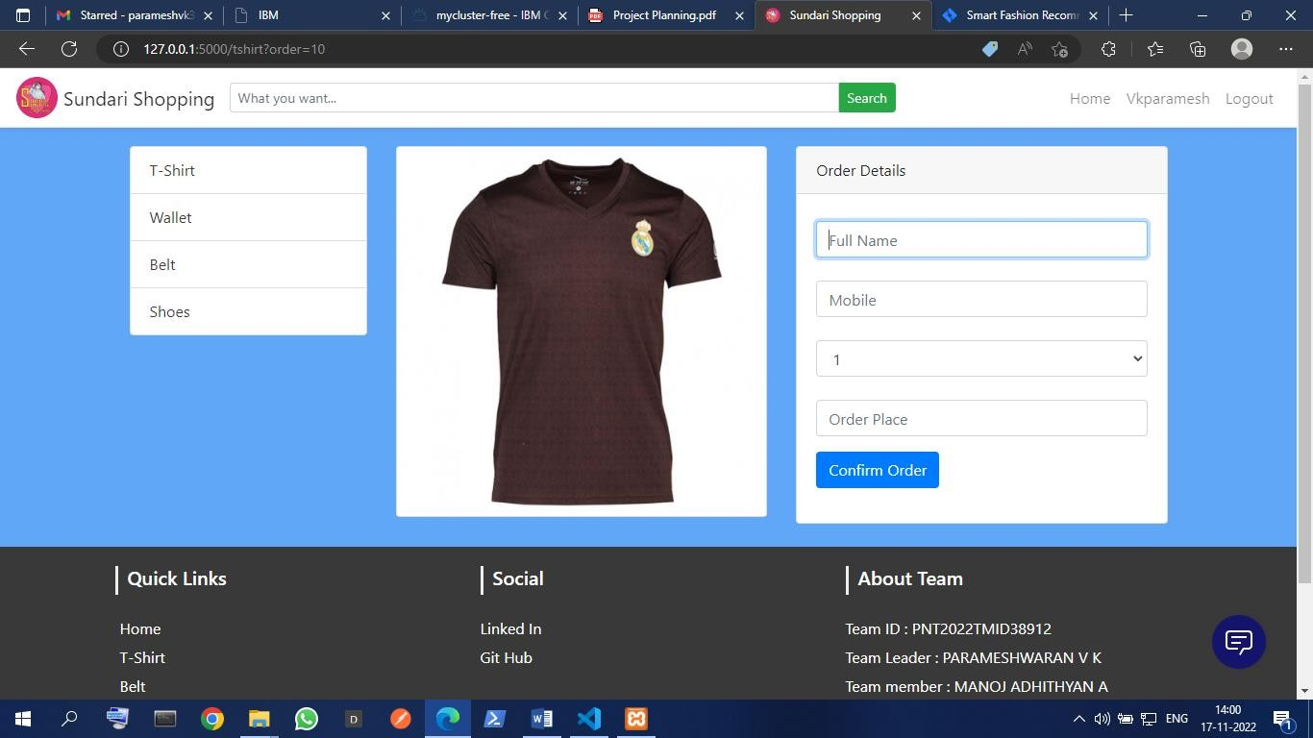

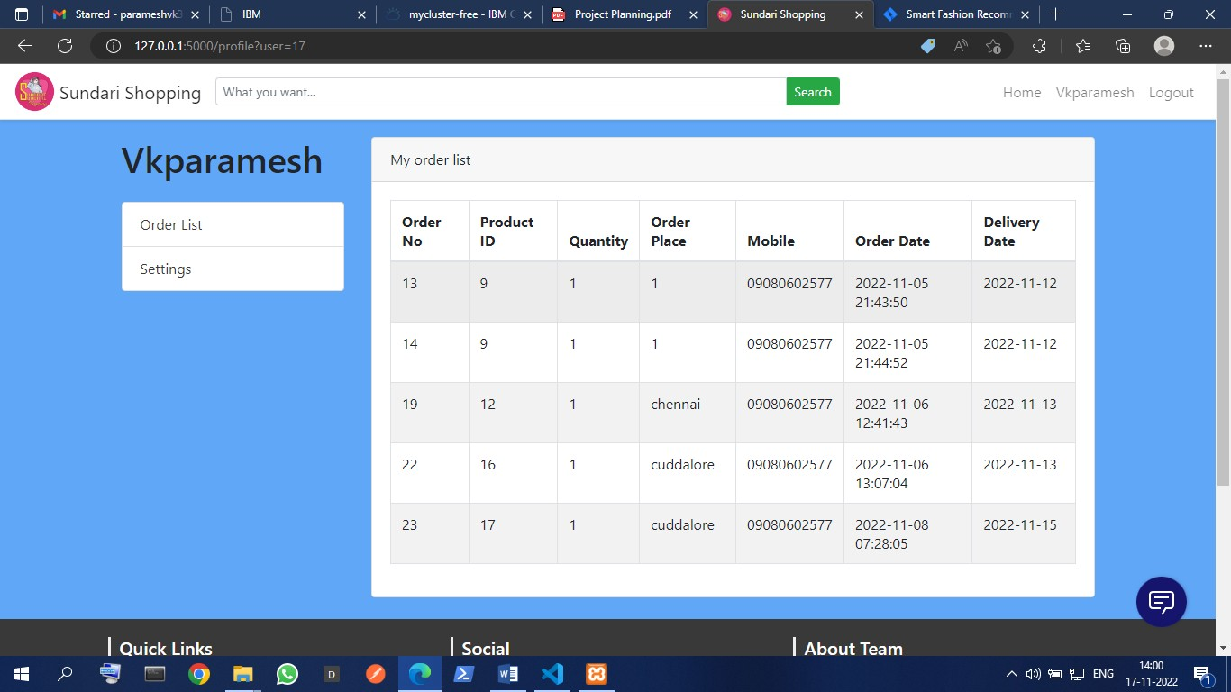Creating Cart page

Create Database For products and user details

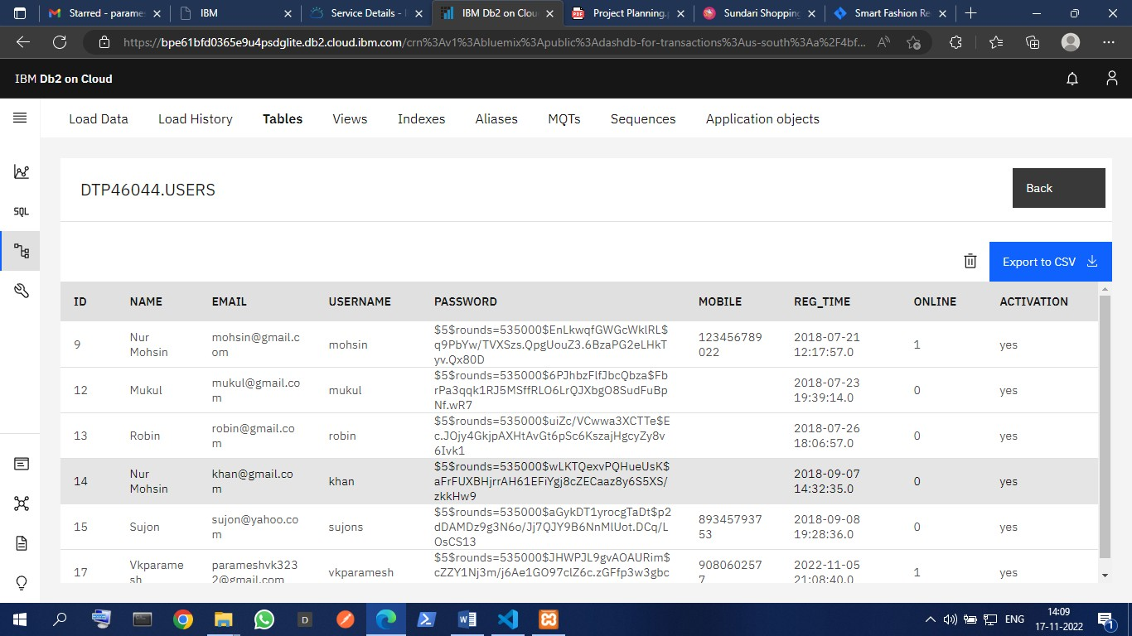

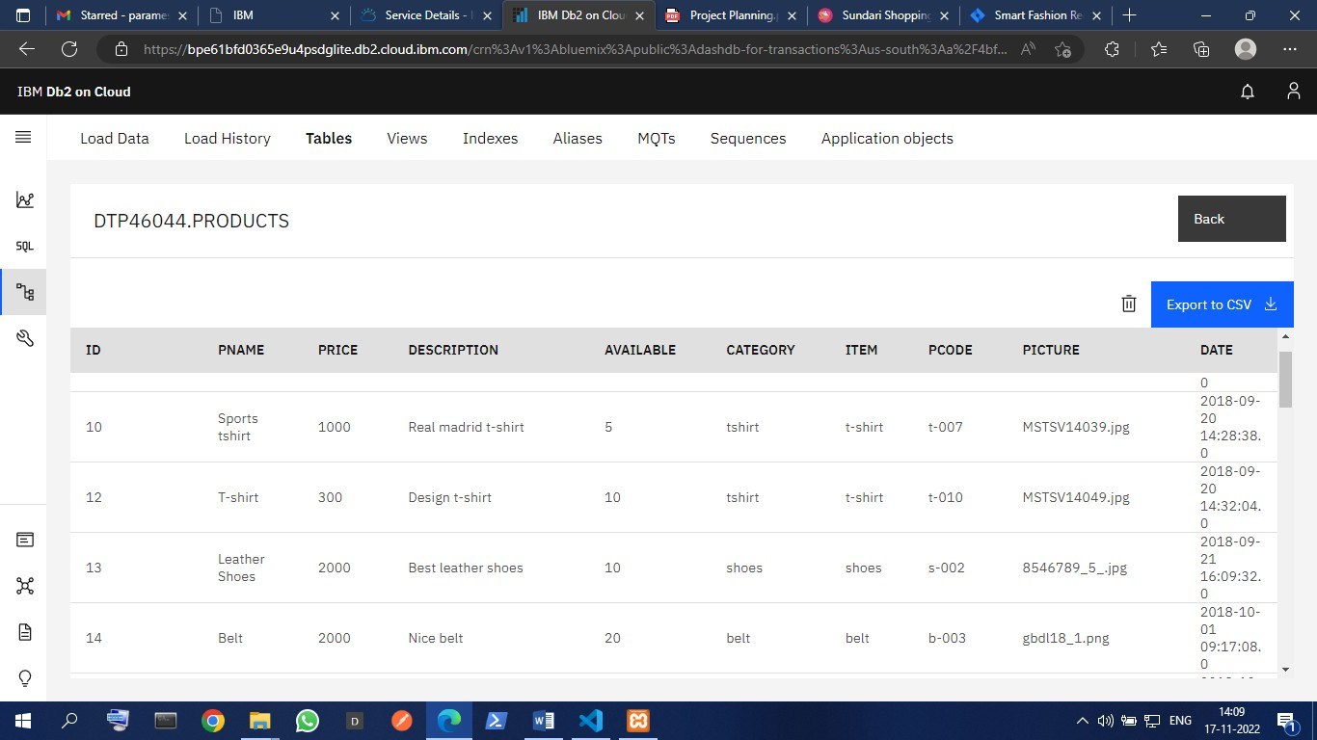

Completing the User panel

